**FitTrack Pro**

Project Submitted to the

**SRM University AP, Andhra Pradesh**

for the partial fulfillment of the requirements to award the degree of

**Bachelor of Technology in**

**Computer Science & Engineering**

**School of Engineering & Sciences**

Submitted by

Sura Bhaavya (AP23110011222)

U Rohini (AP23110011253)

Tarimela Sreeya (AP23110011258)

L Deekshitha (AP23110011634)



Department of Computer Science & Engineering

SRM University-Ap

Neerukonda, Mangalgiri, Guntur

Andhra Pradesh - 522 240

Dec 2025

**Acknowledgement**

We would like to express our sincere gratitude to SRM University AP, Andhra Pradesh, for providing us with the opportunity and necessary resources to successfully complete the project “FitTrack Pro” as part of the partial full fillment of the requirements for the award of the Bachelor of Technology in Computer Science & Engineering. We extend our heartfelt thanks to the School of Engineering & Sciences and the Department of Computer Science & Engineering for their continuous support, encouragement, and academic environment that made this project possible.

We are deeply grateful to our project guide and faculty members for their valuable guidance, constructive feedback, and technical insights, which played a vital role in shaping and improving this project. We also acknowledge the support of our friends and classmates for their discussions, suggestions, and motivation during the development phase, making the learning experience both productive and enriching.

Contents

Introduction: 2

Scenario-Based Intro: 2

Target Audience: 3

Project Goals and Objectives: 4

Key Features: 5

PRE-REQUISITES: 6

PROJECT STRUCTURE: 7

PROJECT FLOW: 8

Milestone 1: Setup 9

Milestone 2: Web Development 9

Milestone 3: Backend Logic (storage.js) 14

PROJECT EXECUTION 16

APPLICATION SCREENSHOTS : 16

Conclusion 23

# Introduction:

FitTrack Pro is a modern and intuitive fitness tracking application designed to help users understand, monitor, and improve their overall health. Built using React, it brings together a clean interface, smart features, and interactive visuals that make fitness tracking both simple and enjoyable.

Instead of juggling multiple apps or complicated dashboards, FitTrack Pro gives you everything in one place — workout logs, sleep tracking, hydration reminders, calorie trends, streaks, and detailed weekly reports. Whether you’re a beginner starting your fitness journey or someone who trains regularly, the app adapts to your needs and provides clear insights that help you stay motivated and consistent.

With features like real-time calorie estimation, dynamic charts, a GitHub-style activity heatmap, and one-click PDF report generation, FitTrack Pro turns your daily fitness routine into a smooth, engaging experience. It focuses on privacy, personalization, and user control, ensuring that your health data stays with you.

Overall, FitTrack Pro aims to make fitness tracking feel effortless, meaningful, and motivating — helping users build healthier habits and stay connected to their progress every day.

# Scenario-Based Intro:

Imagine waking up on a fresh morning, coffee in hand, feeling ready to begin your day with a solid workout. You open your go-to fitness companion, **FitTrack Pro**.

The app welcomes you with a clean, personalized dashboard that instantly feels familiar. Its dark theme is easy on your eyes during early hours, while the bright, colorful charts make your progress easy to understand. You log your first workout of the day — a quick 30-minute HIIT session — and as you enter the details, FitTrack Pro automatically estimates how many calories you likely burned based on your weight, workout type, and effort level.

Once your workout is done, you move on to track your recovery. With simple and interactive tools, you update your sleep duration and water intake. FitTrack Pro translates these inputs into clear visual insights, helping you stay motivated and notice healthy (or unhealthy) patterns in your routine.

As the week goes by, you check your activity heatmap — a visual grid inspired by GitHub’s contribution graph — which shows how consistently you’ve been working out. Your growing streak adds a fun, game-like element, encouraging you to keep moving every day.

When you need to review your progress with a trainer or doctor, you simply tap “Generate Report.” In seconds, FitTrack Pro creates a polished, professional PDF filled with charts, statistics, and a detailed breakdown of your workouts.

With these features working together, FitTrack Pro becomes more than an app — it becomes a daily fitness partner that guides, motivates, and helps you stay connected to your goals.

# Target Audience:

FitTrack Pro is designed for a wide range of users, making it easy for anyone to take charge of their health and fitness. It’s especially helpful for:

**• Fitness Enthusiasts**  
People who love staying active and enjoy tracking their workouts, nutrition, and recovery to push their performance and reach new fitness goals.

**• Beginners Just Starting Out**  
Those who are new to fitness and need simple, motivating tools to help them build healthy habits and follow their progress from day one.

**• Athletes & Personal Trainers**  
Both professionals and hobby athletes — along with their coaches — who rely on detailed workout logs, performance metrics, and progress reports to refine training routines.

**• Busy, Health-Conscious Professionals**  
Individuals with tight schedules who still want to maintain a balanced lifestyle by keeping track of their activity, sleep, hydration, and calorie burn.

**• People Focused on Weight Management**  
Anyone aiming to lose or gain weight and who benefits from accurate BMI insights, calorie tracking, and easy-to-read progress visuals that keep them on track.

# Project Goals and Objectives:

The main aim of FitTrack Pro is to create a smooth, easy-to-use fitness tracking experience that feels personal and helpful for every user. To achieve this, the project focuses on the following goals:

* **User-Friendly Interface**  
  We want FitTrack Pro to feel simple and welcoming. Users should be able to log workouts, view trends, and navigate the app without confusion. Everything is designed to make tracking fitness feel natural and effortless.
* **Complete Health Tracking**  
  The app brings all essential wellness tools together — workout logging, sleep tracking, hydration monitoring, and quick search features. This makes it easy for users to view and understand their health data in one place.
* **Privacy First**  
  Your health information is personal. FitTrack Pro ensures that all user data stays under the user's control — stored locally or on their own server. There’s no dependency on third-party cloud services, ensuring complete privacy and ownership.
* **Built With Modern Technology**  
  FitTrack Pro is developed with a modern tech stack, including React.js for the interface, Recharts for beautiful visualizations, Framer Motion for smooth animations, and jsPDF for generating polished PDF reports. These tools work together to create a fast, reliable, and enjoyable experience.
* **Motivation Through Gamification**  
  To help users stay consistent, the app includes streak counters, points, and a visual activity heatmap. These features add a fun, motivating layer to the fitness journey, encouraging users to build healthy habits.

# Key Features:

* **Easy Workout Logging**  
  Log all kinds of workouts — running, cycling, HIIT, yoga, swimming, and more — along with duration, intensity, heart rate, calories, RPE, and personal notes.
* **Real-Time Calorie Estimation**  
  Get instant calorie burn estimates based on your weight, workout type, and effort level.
* **Insightful Dashboard Analytics**  
  View clear charts showing trends in calories, steps, sleep, hydration, workout types, and intensity throughout the week.
* **Activity Heatmap**  
  See your yearly workout consistency at a glance with a GitHub-style heatmap.
* **Sleep & Hydration Tracking**  
  Track your sleep hours and daily water intake through simple, interactive tools.
* **Streaks & Motivation Boosters**  
  Stay motivated with streak tracking, points, and visuals that reward consistency.
* **BMI & Health Insights**  
  Check your BMI instantly with visual indicators and simple health guidance.
* **One-Click PDF Reports**  
  Generate clean, professional weekly reports that include charts, stats, and workout logs.
* **Smart Search & Filters**  
  Quickly find past workouts by type or keywords in your notes.
* **Responsive & Dark Mode Ready**  
  Enjoy a smooth experience on any device, with optional dark mode for comfortable viewing.
* **Smooth Animations**  
  Enjoy polished transitions and subtle motions powered by Framer Motion.
* **Multi-User Accounts**  
  Support for multiple profiles with secure login and separate workout histories.
* **Personalized Profiles**  
  Set up details like age, height, weight, and daily goals for a more accurate and tailored experience.

# PRE-REQUISITES:

Before building FitTrack Pro, a few tools and basic knowledge are needed:

**1. Node.js & npm**

Node.js lets you run JavaScript outside the browser, while npm helps you install libraries.  
You’ll need both to run and manage your React project.

**2. React.js**

React is the core of FitTrack Pro. It allows you to create fast, interactive UI components.  
Setup steps with Vite:

npm create vite@latest

→ choose project name (e.g., fittrack-pro)

→ select React

cd fittrack-pro

npm install

npm run dev

Open the app in your browser at [**http://localhost:5173**](http://localhost:5173).

**3. Basic Web Skills**

A good understanding of HTML, CSS, and JavaScript will help you build the UI and interactions.

**4. Version Control (Git)**

Git is used to track project changes and collaborate.  
Platforms like GitHub or Bitbucket store your repository online.

**5. Code Editor**

Choose any editor you prefer. Common choices include:

* VS Code
* Sublime Text
* WebStorm

# PROJECT STRUCTURE:

The project is organized to keep everything clean, consistent, and easy to maintain:

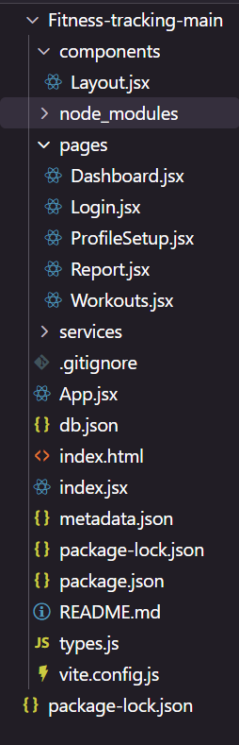

Fitness-tracking-main/

│── components/ → Reusable UI elements (Layout, Navbar, etc.)

│── pages/ → All main screens (Dashboard, Login, Workouts, etc.)

│── services/ → storage.js for data handling and API calls

│── App.jsx → App routes and global logic

│── index.jsx → React entry point

│── db.json → JSON Server database

│── types.js → Shared data types

└── vite.config.js → Vite configuration

This structure keeps your logic organized and makes teamwork easier.

# PROJECT FLOW:

**Project demo:**

Before starting to work on this project, let’s see the demo.

Demo link:

<https://drive.google.com/file/d/1sXXu7zWuTzFF59SAXLfAQeKQ_76BMlF9/view>

Use the code in:

<https://drive.google.com/file/d/1VgOo09XrdniU7wJ1sCEH065Gs2l0sHJe/view>

## Milestone 1: Setup

* Install required tools
* Create React app with Vite
* Install necessary libraries:
  + React Router
  + Recharts
  + Framer Motion
  + React Toastify
  + Lucide React
  + jsPDF & html2canvas
  + JSON Server
* Configure routing, theme, and initial folder structure

## Milestone 2: Web Development

**1. Build the React App**

* Configure routing using react-router-dom
* Set up JSON Server for a mock backend
* Add toast notifications and page transitions

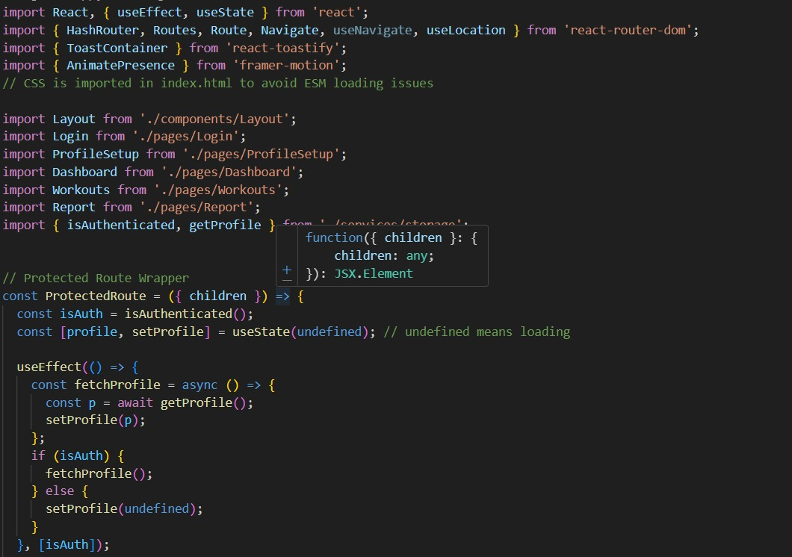

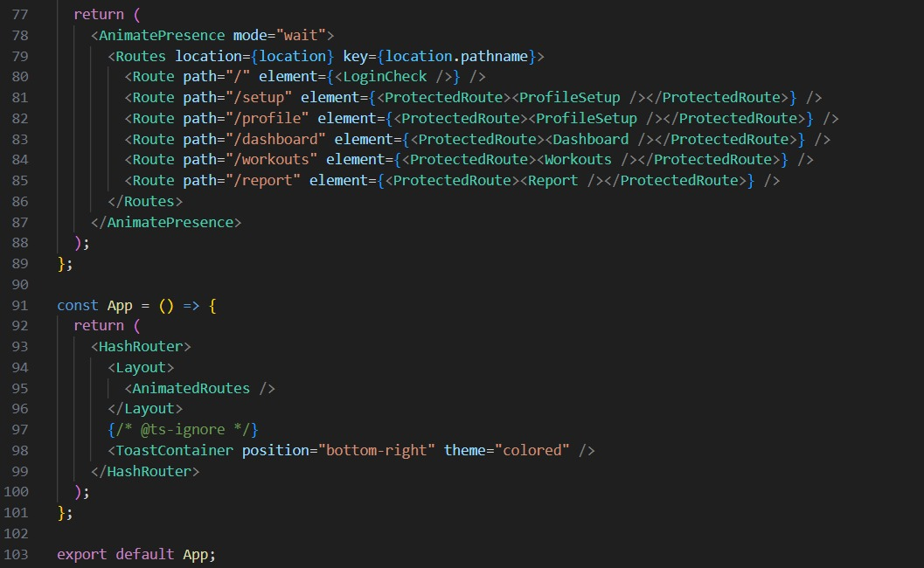

**2. Design UI Components**

**Layout Component**

* Contains navigation bar and main UI structure
* Shows active route highlights
* Includes logout functionality
* Responsive with dark mode support

**Dashboard**

* Displays key stats: steps, calories, sleep, water
* Weekly charts using Recharts
* GitHub-style heatmap to show activity consistency
* Smooth animations powered by Framer Motion

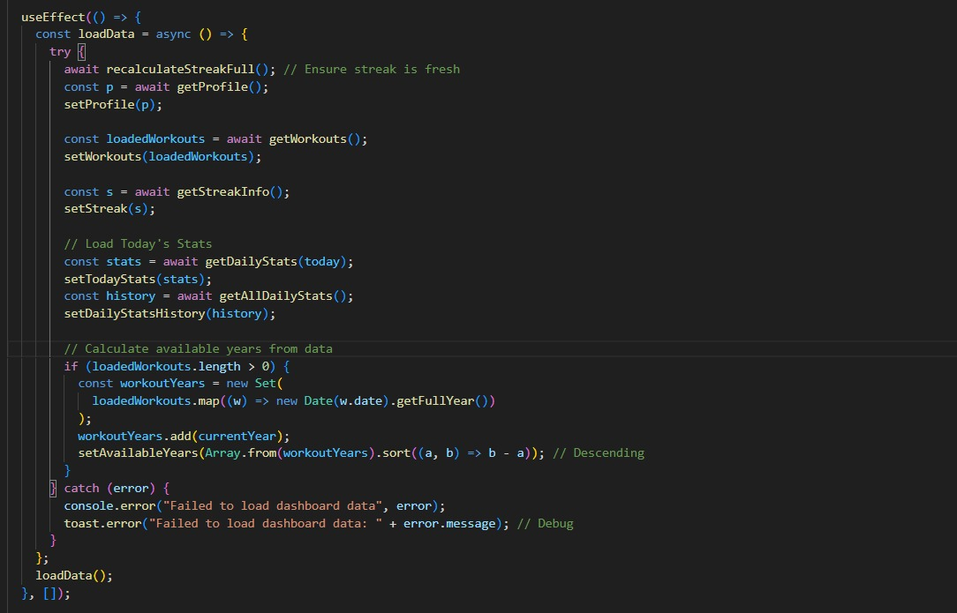

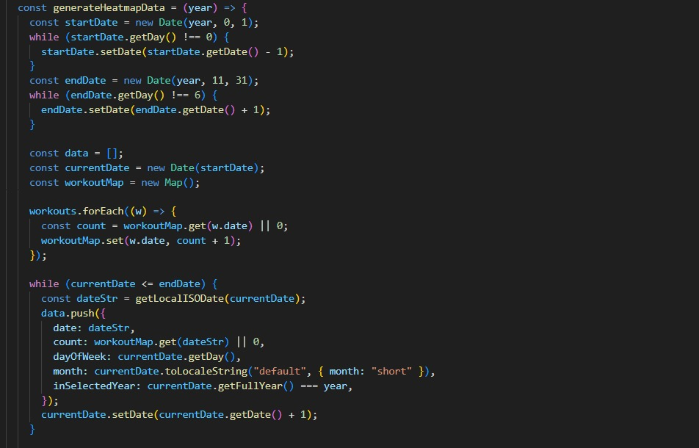

**Workouts Page**

* Complete workout entry form
* Live calorie estimation
* Search and filter workouts
* Edit and delete entries
* Animated modals for adding/editing sessions

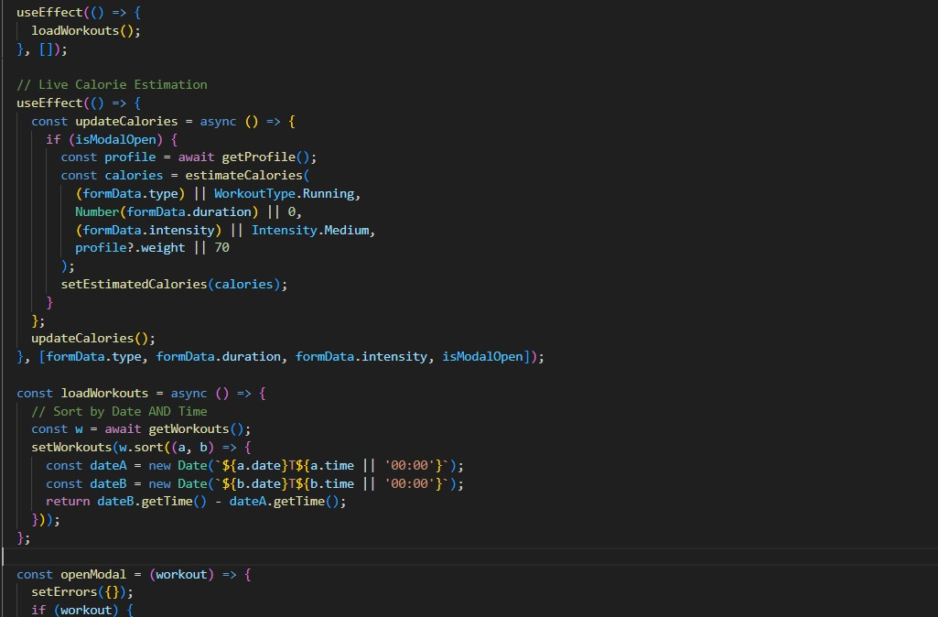

**Profile Setup**

* Multi-step form for personal details, body stats, and goals
* Real-time BMI calculation with color-coded categories
* Clean layout with helpful insights

**Report Page**

* Professional report layout
* Recent workouts, stats, charts
* One-click PDF generation using jsPDF + html2canvas
* Forces light theme for clean print output

## Milestone 3: Backend Logic (storage.js)

The storage.js file handles:

* User authentication
* Storing and retrieving profile data
* Workout CRUD operations
* Calorie estimation using MET values
* Sleep and hydration tracking
* Streak and points calculation
* Isolating data per user
* JSON Server communication

All backend logic is neatly centralized for easier maintenance.

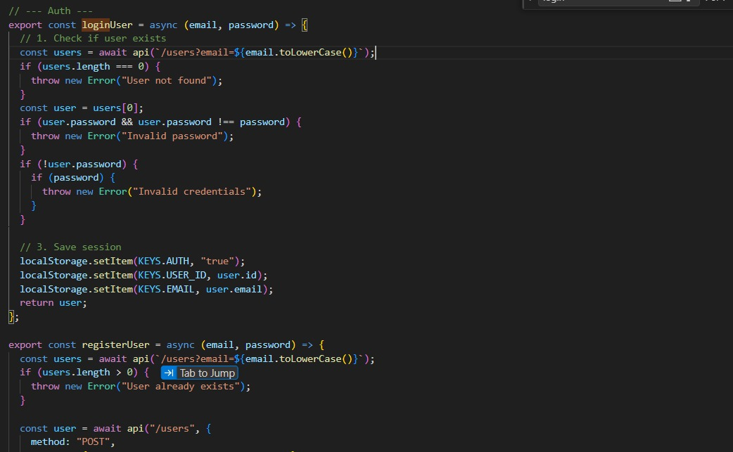

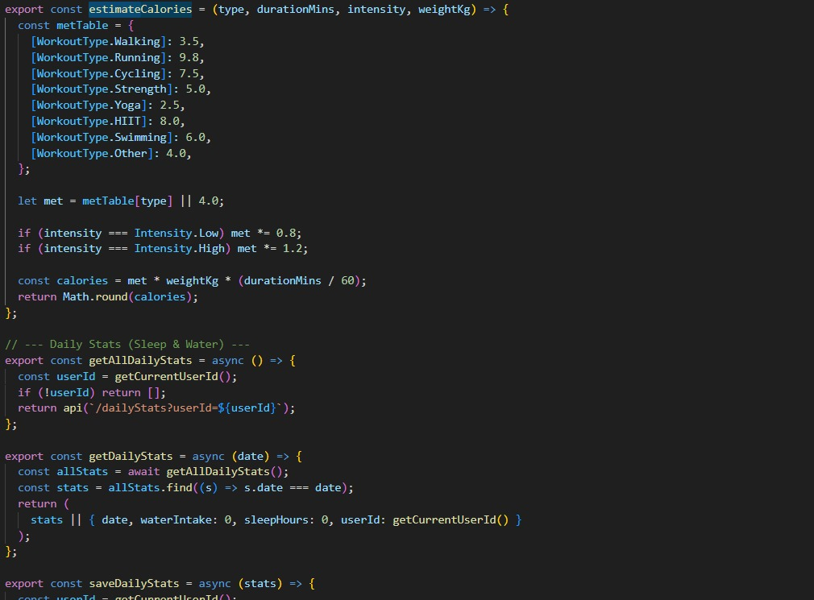

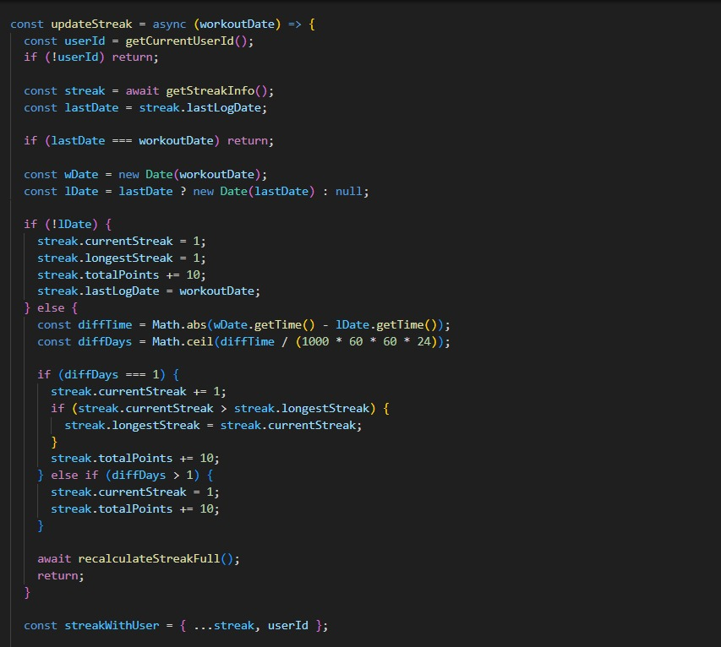

# PROJECT EXECUTION

**1. Start JSON Server**

npm run server

Runs at: [**http://localhost:3001**](http://localhost:3001)

**2. Start React App**

npm run dev

Runs at: [**http://localhost:5173**](http://localhost:5173)

**3. Open the App**

Visit [**http://localhost:5173**](http://localhost:5173) in your browser.

## APPLICATION SCREENSHOTS :

**Login Page**

* Simple and clean login/register form
* Error messages for invalid inputs
* Background gradients and responsive layout

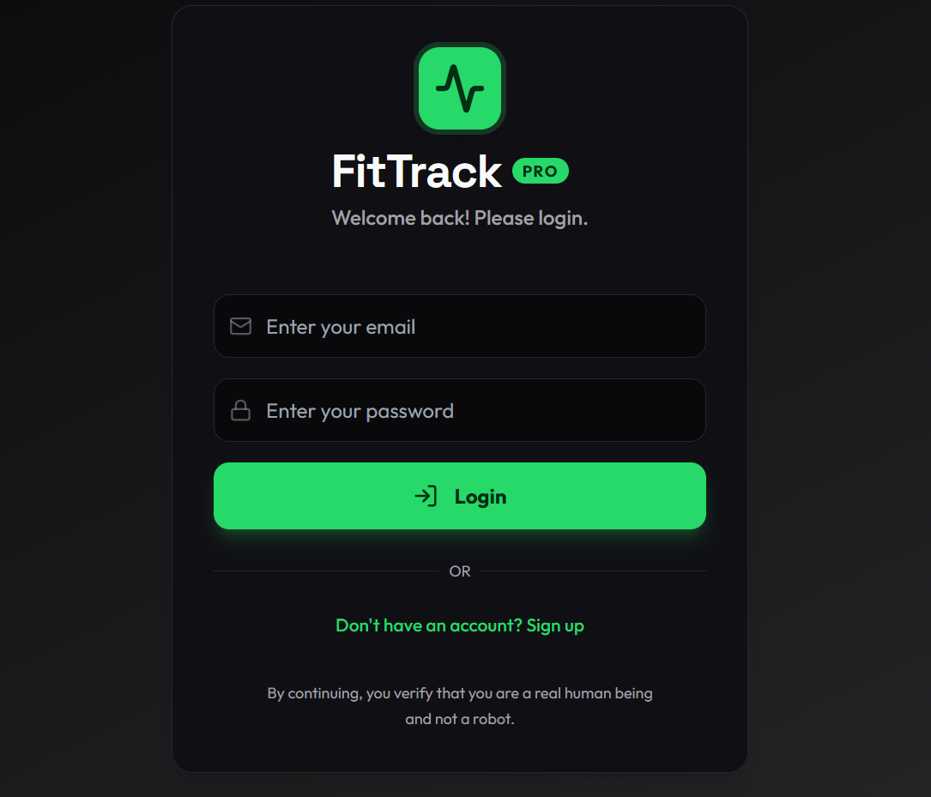

**Profile Setup**

* Guided form for personal info, stats, and goals
* Live BMI calculation with a colored gauge
* Helpful sidebar with insights

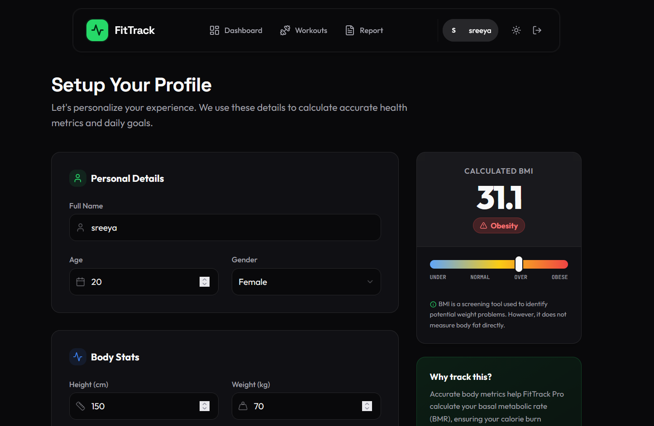

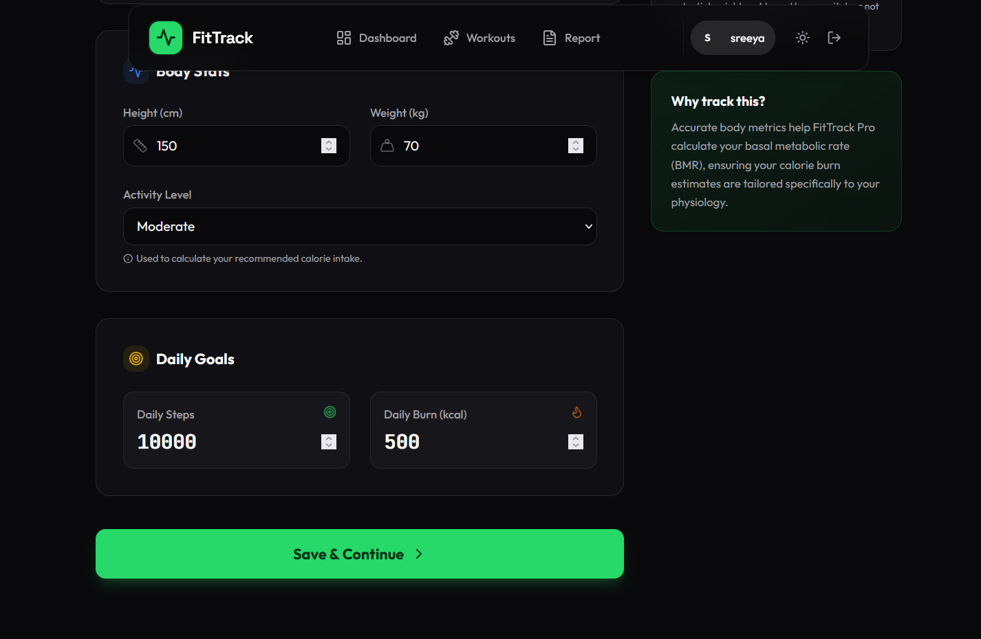

**Dashboard**

* Daily summary cards (steps, calories, sleep, water)
* Multiple charts (bar, line, area, pie)
* Yearly activity heatmap
* Smooth transitions and animations

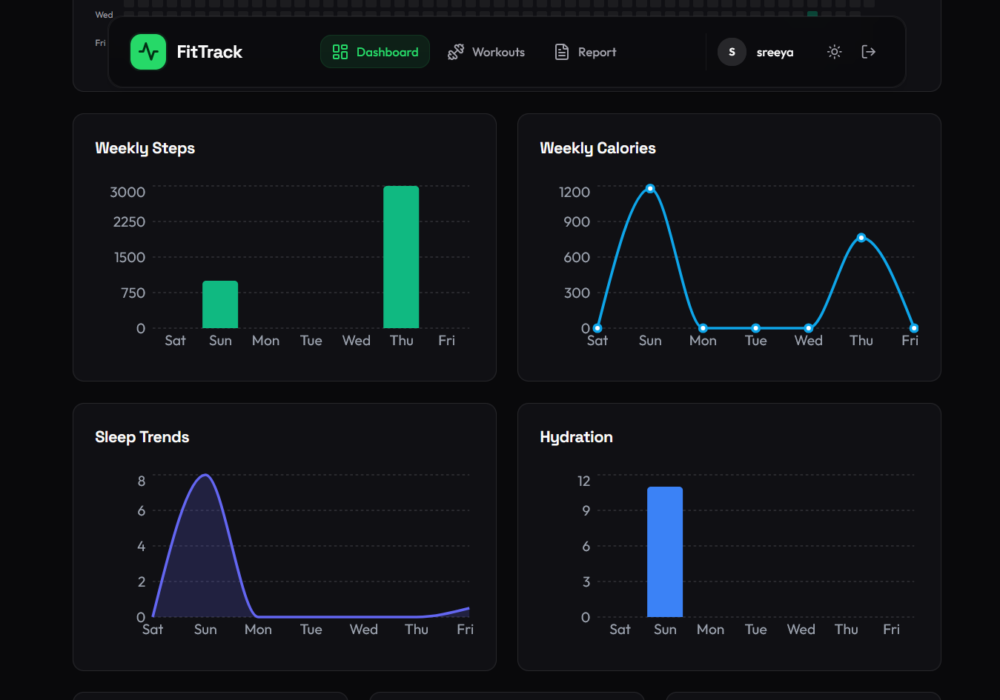

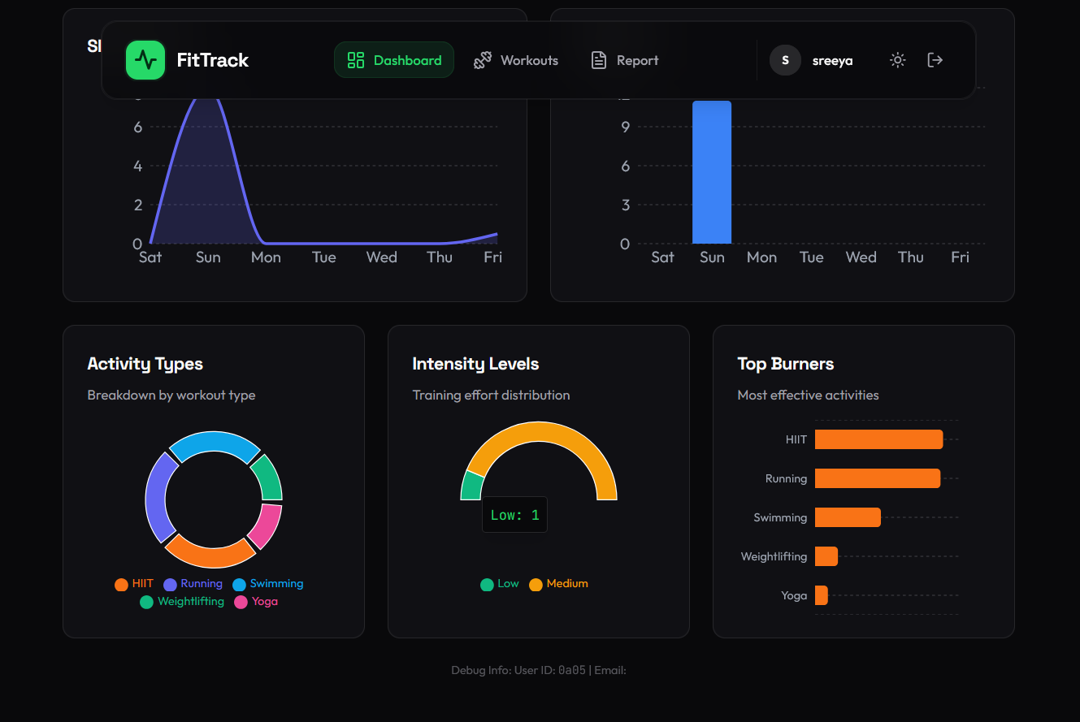

**Workouts Page**

* Detailed workout form
* Instant calorie estimation
* Search and filters
* Edit/delete options
* Animated modal popup

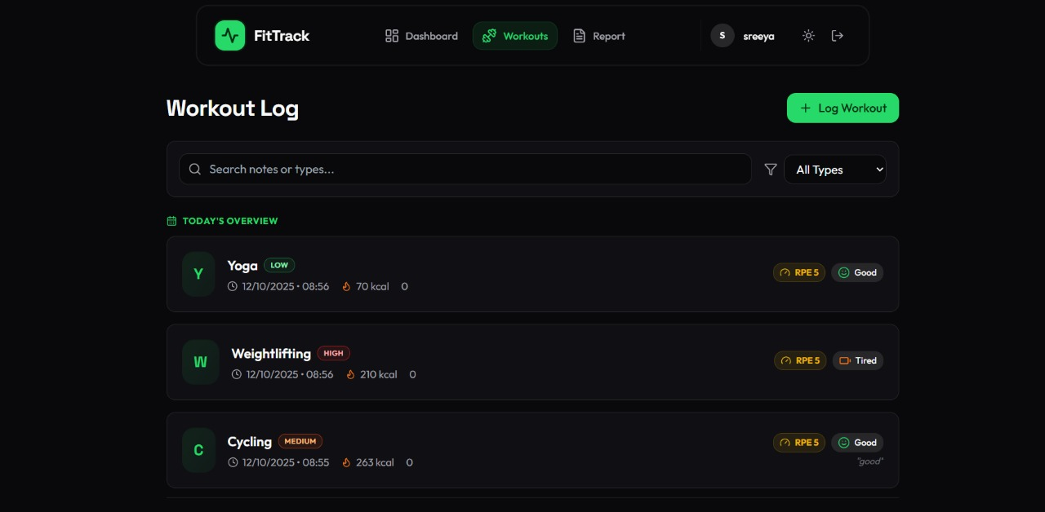

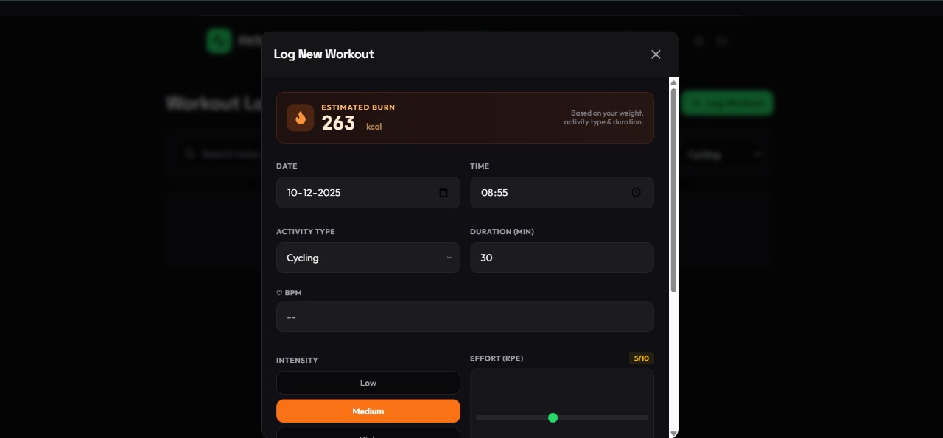

**Report Page**

* Clean, printable weekly report layout
* Calories trend chart
* Recent workouts table
* One-click PDF download

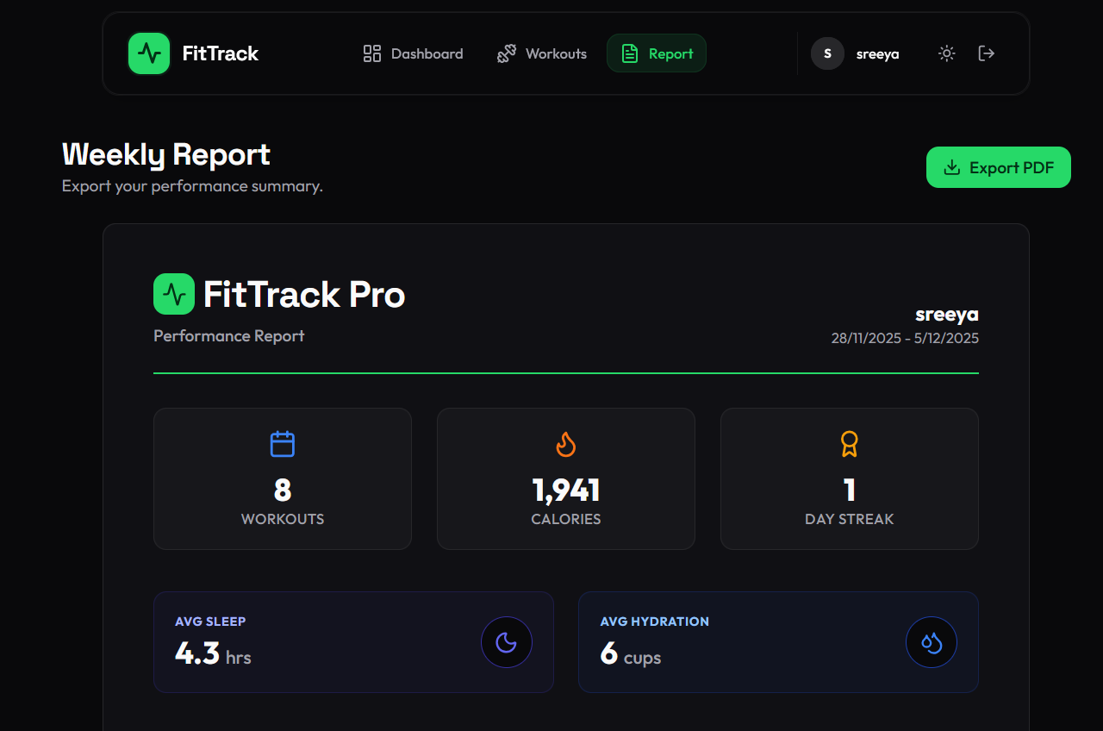

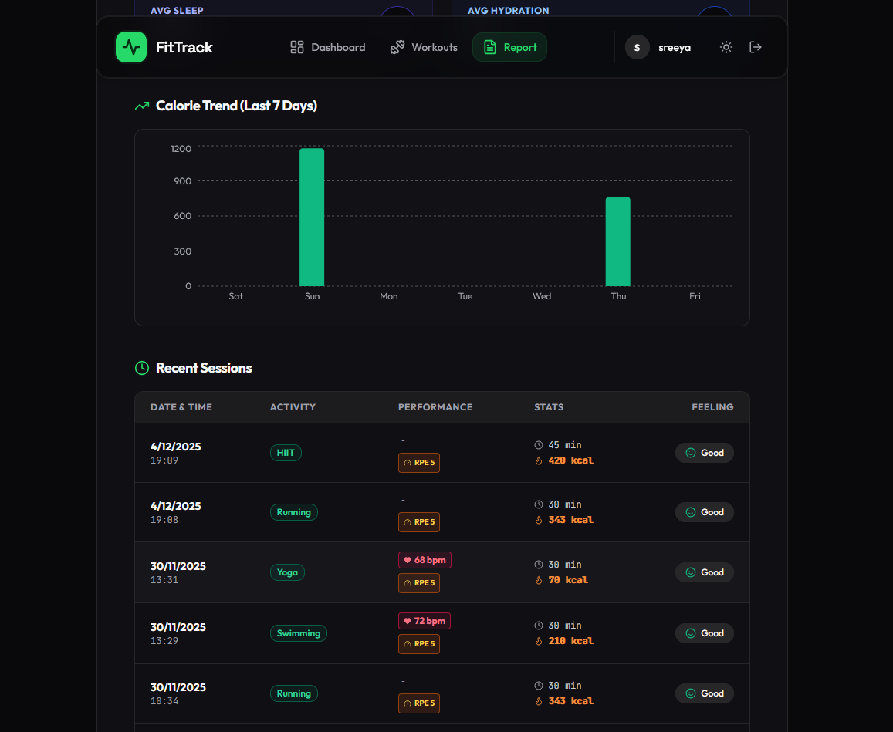

**Exported PDF File:**

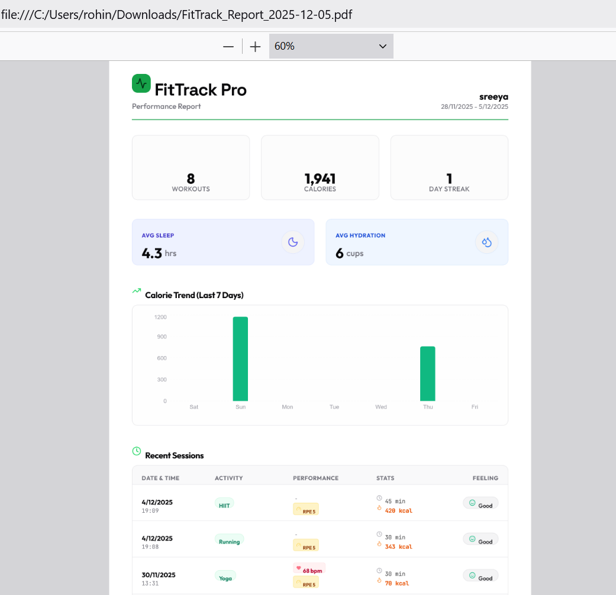

**Final Application**

* Fully responsive design
* Dark mode support
* Smooth page transitions
* Toast notifications
* Multi-user authentication

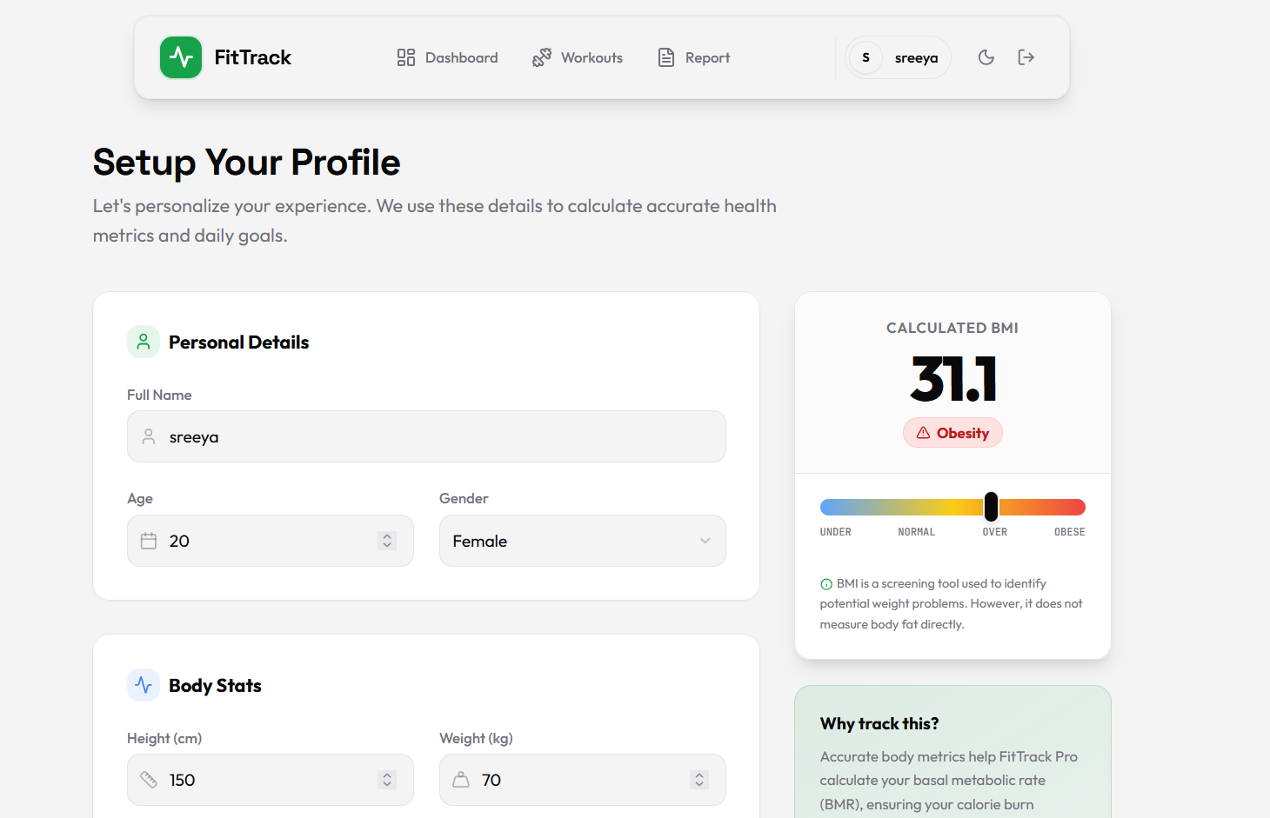

# Conclusion

**FitTrack Pro** successfully demonstrates the design and development of a modern, full-stack single-page application (SPA) focused on health and fitness. By utilizing the **React** ecosystem for a dynamic frontend and **JSON Server** for a structured backend, the project achieves a seamless, responsive user experience.

Overall, FitTrack Pro not only fulfills the functional requirements of a fitness tracker but also serves as a comprehensive example of modern web development practices, integrating authentication, CRUD operations, and data visualization into a unified, high-performance platform.